B O O K O F I N T R O D U C T I O N
LENA
لينا: Live Emotional Needs Assistant (لين Layn)
AI-Powered Mental Health Web Platform
Integrating Self-Assessment, Mood Tracking, Cognitive Behavioural Therapy
& Spiritual Wellness for Communities in Malaysia.
International Islamic University Malaysia (IIUM)
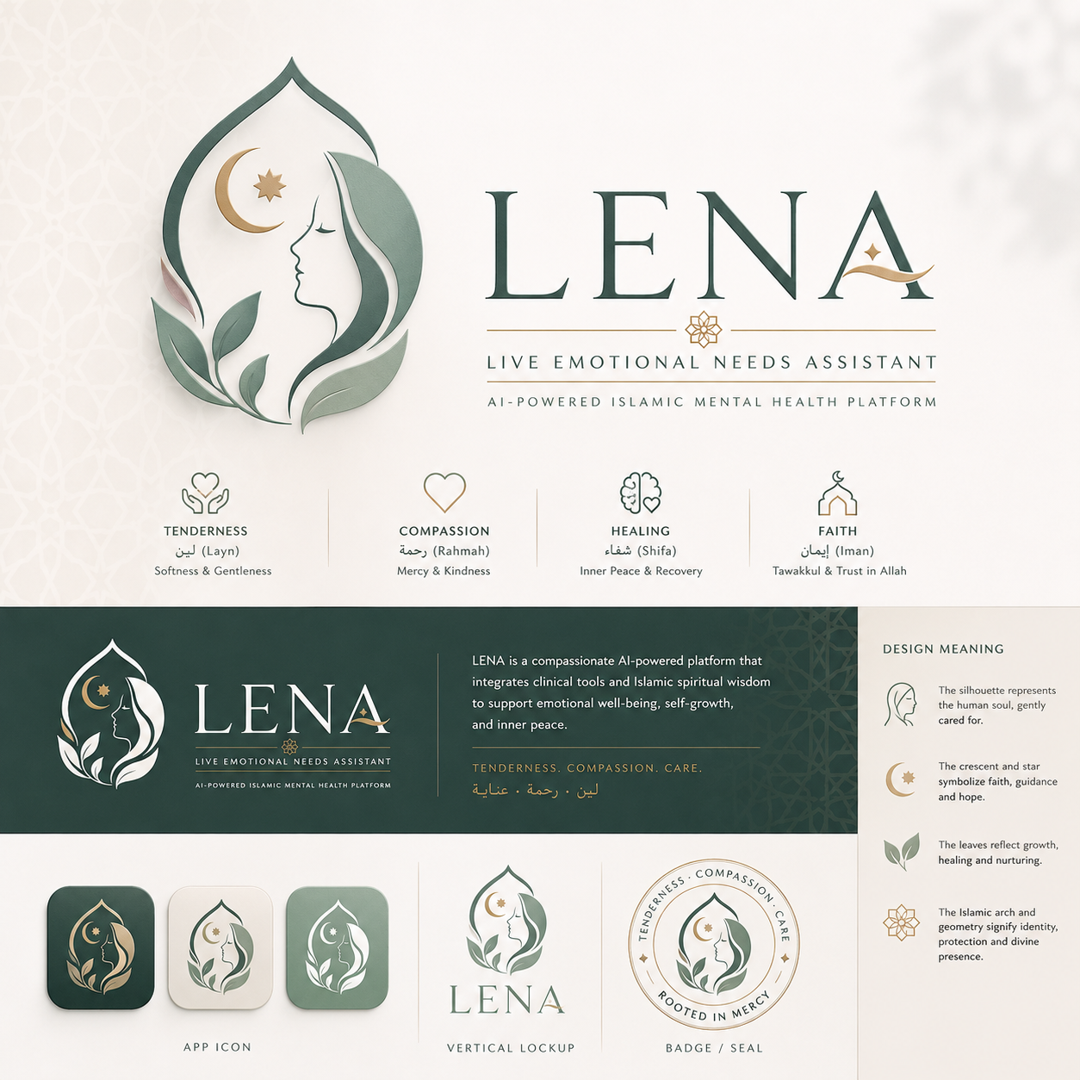
Kulliyyah of Information & Communication Technology (KICT) · Computer Science Dept. · 2026

Table of Contents

01 Preface
02 Why LENA? (Platform Identity, Name & Arabic Root)
03 Research Team: Meet the KICT Team
04 Project Objectives: 4 Core Goals
05 The Problem: Why This Platform Is Needed
06 Vision & Mission: What LENA Stands For
07 Existing Platform Analysis: Top 5 Apps Reviewed
08 Comparative Analysis: Apps at a Glance
09 Drawbacks of Existing Apps: Identified Gaps
10 Key Insights & Why LENA Must Be Executed: 7 Evidence-Based Reasons
11 LENA Solution: Our Approach & Differentiation
12 Key Features: What LENA Offers
13 Clinical Integration: Hospital Partnership
14 Development Roadmap: From Concept to Community
15 From the Meeting Room: Key Agreements, 8 May 2026
16 Closing: A Platform Built With Purpose
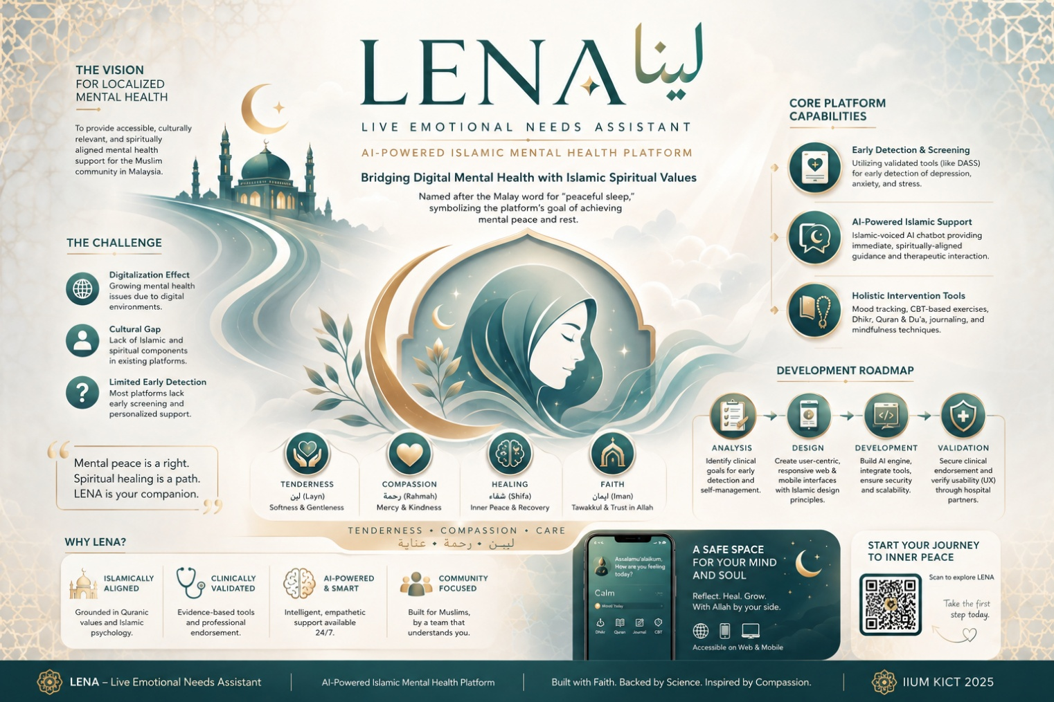
01 Preface
In the Name of Allah, Most Gracious, Most Merciful
Mental health challenges are among the most pressing yet under addressed issues facing Muslim youth today. Cultural stigma, limited access to culturally sensitive care, and a disconnect between clinical approaches and spiritual beliefs create significant barriers to seeking help. LENA was conceived to bridge this gap. It is a platform where healing is approached with both clinical rigour and deep Islamic wisdom.
The name LENA (لينا) carries a layered and profound identity rooted in both Arabic linguistics and Malay culture. Academically, the name is derived from the Arabic root لين (layn / لين), conveying the quality of tenderness, gentleness, softness, delicacy, and compassion. Related Arabic name forms include Lina, Leena, Liyana, and Layyin, all of which share this same root and semantic field. These qualities are deeply aligned with the Islamic understanding of mercy (Rahmah), emotional care, and the nurturing of the human soul.
In Malay, the word “lena”, as in “Tidur Lena”, means deep, restful, undisturbed sleep. This dual cultural resonance is intentional: LENA speaks to both the Arabic tradition of compassionate care and the Malay aspiration for inner peace and restorative rest. It is a name that belongs to the community it was built for.

Etymology Reference
Arabic Root | Related Names | Core Meanings | Islamic Resonance
لين (Layn)  Softness / Gentleness | Lena / Lina  Leena / Liyana / Layyin | Tenderness  Gentleness  Softness / Delicacy  Compassion | Rahmah (Mercy)  Emotional care  Nurturing the soul  Islamic kindness

A more polished academic rendering: “The name LENA draws inspiration from Arabic linguistic roots associated with tenderness, gentleness, softness, and compassion, which are the qualities deeply aligned with the Islamic understanding of mercy, emotional care, and the nurturing of the human soul.”

“LENA is more than an acronym. It is a compassionate companion that guides users toward emotional balance, and in Malay culture, it beautifully represents the deep inner peace we all seek.”

02 Why LENA?
Live Emotional Needs Assistant: Meaning & Linguistic Identity
LENA is both an acronym and an identity. Each letter captures a core therapeutic and philosophical pillar of the platform:

L (Live)  Real-time emotional support and mood tracking, aligned with Ecological Momentary Assessment (EMA) in clinical psychology. Users receive immediate, contextually relevant support at any moment. | E (Emotional)  Fulfilling core psychological needs based on Self-Determination Theory, which consist of autonomy, competence, and relatedness. The emotional layer is the heart of LENA, driving everything from the AI chatbot to journaling.
N (Needs)  Addressing what users truly need: clinical tools (PHQ-9, GAD-7, CBT exercises), spiritual guidance, and compassionate AI support, all of which is available free of charge. | A (Assistant)  An always-available companion using CBT techniques and spiritual guidance for self-management. Available 24/7, non-judgmental, and personalised to each user’s unique journey.

A Note on Linguistic Identity
While LENA functions as an acronym for Live Emotional Needs Assistant, the name was also deliberately chosen for its Arabic-Malay resonance. The Arabic root لين (layn) underlies related names such as Lina, Leena, Liyana, and Layyin, all carrying meanings of softness, gentleness, tenderness, and delicacy. This root is semantically connected to the Quranic value of Rahmah (mercy) and the Islamic ideal of emotional care for the human soul.
The name is therefore both functionally descriptive and spiritually grounded, a dual identity that mirrors the platform’s own dual commitment to clinical science and Islamic wisdom.

03 Research Team
KICT’s Interdisciplinary Team (IIUM)
LENA is developed by an interdisciplinary team from the Kulliyyah of Information & Communication Technology (KICT) at the International Islamic University Malaysia (IIUM), combining academic expertise in computer science with clinical collaboration:

Name | Role | Department | Institution
Ts. Dr. Ahmad Anwar Bin Zainuddin | Platform Lead & Principal Investigator | Computer Science | IIUM
Asst. Prof. Dr. Amir ‘Aatieff Bin Amir Hussin | Co-Investigator | Computer Science | IIUM
Ts. Dr. Dini Oktarina Dwi Handayani | Co-Investigator | Computer Science | IIUM
Muhammad Ilham Bin Mohd Hisham | 3rd Year CS Student (Developer) | Computer Science | IIUM
Muhammad Ikhwan Bin Mat Suhairi | 3rd Year CS Student (Developer) | Computer Science | IIUM
Dr. Hamidah | Clinical Advisor & Ethical Oversight | Psychiatry | NH Health Centre

The team is further supported by Dr. Hamidah, a clinical psychiatrist and Director of NH Health Centre (Siti Wangsa), who serves as Clinical Advisor and provides ethical oversight, clinical validation, and facilitates access to local Malaysian mental health data through formal institutional partnership.

04 Project Objectives
Four Core Goals Driving LENA

01 Analyse Existing Platforms  To analyse existing digital mental health platforms and identify key functional requirements aligned with clinical goals of early detection, self-management, sustained engagement, and equitable access. | 02 Design a User-Centred Platform  To design a user-centred, responsive web-based mental health support platform incorporating validated self-assessment tools, mood tracking, CBT-based exercises, and psychoeducational resources.
03 Implement a Functional Prototype  To implement a functional prototype of the LENA platform using standard web technologies, adhering to established usability heuristics and accessibility guidelines. | 04 Evaluate Usability & UX  To evaluate the usability and user experience of the developed prototype through systematic heuristic evaluation and user feedback analysis.

05 The Problem
Why This Platform Is Urgently Needed
Malaysia, like much of the Muslim world, faces a growing mental health crisis among youth. The situation is compounded by several intersecting systemic failures:

Cultural Stigma  Mental health issues are heavily stigmatised in Malaysian society. Many individuals, particularly youth, avoid seeking help due to fear of judgement from family and community. | Neurodivergence Invisibility  Neurodivergent individuals, such as those with ADHD, autism, and related conditions, are largely invisible within both clinical and religious support spaces in Malaysia.
Secular Platform Bias  Existing global platforms (Calm, Headspace, Wysa) are Western in design and secular in orientation, providing little to no Islamic or Malay cultural adaptation. | Lack of Local Data  There is a critical shortage of locally collected Malaysian mental health data, making it impossible to clinically validate tools for the local population using existing apps.
Access Barriers  Premium paywalls ($12.99 to $14.99/month) and mobile-only designs exclude students and lower-income users who are most in need of mental health support. | No Culturally-Integrated Spiritual Wellness  None of the leading platforms integrate faith-based practices as part of a therapeutic framework. For Muslim users specifically, practices such as Dhikr and Quranic reflection carry clinically meaningful calming and grounding effects. Yet, no existing platform treats these as therapeutic tools. Non-Muslim users equally lack culturally resonant spiritual wellness pathways tailored to Malaysian communities.

06 Vision & Mission
What LENA Stands For
“To provide every Muslim individual with a compassionate, intelligent, and spiritually grounded companion for mental wellness, one that is accessible, stigma-free, and rooted in faith.”

LENA's mission is to develop an AI-powered web platform that integrates evidence-based mental health tools, including clinical self-assessment, CBT-based exercises, and mood tracking with an optional Spiritual Wellness (Kerohanian) module designed to support users who draw meaning from faith as part of their healing journey. The platform is inclusive by design, welcoming users of all backgrounds, while offering culturally resonant content for the Malaysian Muslim community. The platform is guided by four integrated pillars:

Clinical Validation  All assessment tools and therapeutic content are evidence-based and clinically validated with local Malaysian data, in partnership with hospital mental health departments. | Cultural Relevance  LENA is designed specifically for Malaysian Muslim youth, designed with Bahasa Malaysia support, local idioms, and content that resonates with Malaysian lived experience.
Faith-Integrated Wellness (Spiritual)  For users who draw strength from faith, spiritual wellness is treated as a clinical tool, not an add-on. Islamic practices such as Dhikr and reflective content are available as a dedicated therapeutic pathway, personalised to the user's profile. The platform remains fully functional and clinically complete for all users, regardless of faith background. | Equity of Access  All core features are free. LENA is web-first, accessible on any browser without downloading an app, removing both financial and technical barriers to help.

07 Existing Platform Analysis
Top 5 Mental Health Apps Reviewed
Five leading mental wellness platforms were systematically reviewed across four dimensions: UI/UX design, clinical tool depth, accessibility, and cultural adaptability. The review informed LENA’s feature architecture and design rationale.

Calm (Sleep & Relaxation)  Mobile & Web (USA).  Premium cinematic design. Guided meditations, Celebrity Sleep Stories, breathing exercises, mood check-ins.  Strengths: Stunning production quality, high retention.  Weaknesses: most content paywalled ($14.99/month), limited CBT tools, lifestyle-focused rather than therapeutic. | MindDoc (Mood Tracking & CBT)  Mobile-only (Germany).  Clean clinical design. Daily mood tracking, 14-day health assessments, CBT-based courses, provider-ready reports.  Strengths: evidence-based, clinically validated.  Weaknesses: no AI chatbot, limited real-time crisis support, advanced courses paywalled.
Wysa (AI Chat Support)  Mobile-first (India/US).  Friendly penguin mascot interface. AI chatbot, CBT cognitive reframing, mood tracking, crisis SOS.  Strengths: 45+ clinical studies, 24/7 anonymous support.  Weaknesses: AI feels robotic over time, mobile-only, no personalised symptom reports. | Inflow (ADHD Management)  Mobile-only (UK).  ADHD-specific clean design. CBT learning modules, habit building, goal tracking, community co-working sessions.  Strengths: only major ADHD-specific app.  Weaknesses: narrow focus, no sleep/relaxation, high subscription cost.
Headspace (Mindfulness & CBT)
Mobile & Web (USA).
Soft friendly design. 1,000+ guided meditations, CBT programs, mood tracking, AI chatbot Ebb, sleep stories.
Strengths: 8 efficacy studies, 4.8/5 rating from 629K users.
Weaknesses: almost all features paywalled ($12.99/month), no clinical assessments.

08 Comparative Analysis
Apps at a Glance
The table below summarises the five reviewed platforms across key dimensions relevant to LENA’s design goals:

App | Best For | Platform | Free Content | Clinical Tools | Cost | Rating
Calm | Relaxation & sleep | Mobile & Web | Limited | Low | $14.99/month | 4.8 ★
MindDoc | Daily mood tracking | Mobile only | Good | High | Freemium | 4.5 ★
Wysa | 24/7 AI chat | Mobile only | Good | High | Freemium | 4.7 ★
Inflow | ADHD management | Mobile only | Limited | Medium | Subscription | 4.3 ★
Headspace | Mindfulness habits | Mobile & Web | Very Limited | Medium | $12.99/month | 4.8 ★

“Key finding: All five platforms lack Islamic or Malaysian cultural adaptation, representing the singular gap that LENA is uniquely positioned to fill.”

09 Drawbacks of Existing Apps
Feature Gap Analysis
A detailed feature-gap analysis reveals critical deficiencies across all five platforms:

App | Drawback 1 | Drawback 2 | Drawback 3 | Drawback 4 | Cultural Gap
Calm | No AI Chatbot | Heavy Paywall ($14.99) | No CBT Tools | No Symptom Assessment | No Islamic Content
MindDoc | Hidden Crisis Feature | Freemium Barrier | Mobile Only | No AI Chatbot | No Islamic Content
Wysa | AI Repetitiveness | High Subscription Cost | Mobile Only | No Symptom Reports | No Islamic Content
Inflow | ADHD-Specific Only | Strict Paywall | No Sleep/Relaxation | Technical Bugs | No Islamic Content
Headspace | No AI Chatbot | Strict Paywall | No Clinical Assessment | Repetitive Content | No Islamic Content

“Critical observation: All 5 apps lack Islamic cultural adaptation. This is the single most significant and unaddressed gap across the entire market, which is also the founding rationale for LENA.”

10 Key Insights & Why LENA Must Be Executed
Evidence from Platform Analysis, Clinical Discussion & Lived Experience
BACKGROUND
The Preliminary Meeting: Where It All Began
On 8 May 2026, Ts. Dr. Ahmad Anwar Zainuddin (IIUM KICT) convened a preliminary online meeting with Dr. Hamidah, a clinical psychiatrist and Director of NH Health Centre (Setiawangsa), to present the LENA proposal and gather clinical input. The discussion which was conducted in Bahasa Malaysia and English, produced a rich body of evidence that collectively justifies LENA’s immediate execution.

“Saya menghadapi banyak masalah-masalah ni... saya pun ada student saya yang ada mental illness ni. Ada lebih kurang 100 student yang saya dah lalui semua ni. Kebanyakan dia orang ada masalah mental disebabkan kurang kasih sayang.” said Ts. Dr. Ahmad Anwar, on his lived experience as a UIA Fellow (Warden)

Dr. Ahmad Anwar’s motivation for LENA is not purely academic, it is rooted in years of direct engagement with over 100 students experiencing mental health crises as a residential fellow (warden) at UIA. Witnessing self-harm, emotional neglect, and unmet mental health needs firsthand gave him an intimate understanding of what digital support tools must genuinely deliver.

REASON 1
No Comprehensive Malaysian-Islamic Platform Exists
Dr. Ahmad Anwar explicitly observed: existing platforms come from the USA, Germany, India, the UK, but Malaysia has nothing comparable. The few tools that exist locally are neither comprehensive nor widely known.
“Dekat Malaysia sendiri pun tak ada sebenarnya. Dia ada tapi tak komprehensif... kita orang Asian ni kita banyak ada spiritual component.” said Ts. Dr. Ahmad Anwar.
Dr. Hamidah affirmed this strongly, noting that while some apps include mindfulness, the Islamic mode of meditation is fundamentally different. She welcomed the Islamic integration: “Kalau you nak create something Islamic, memang saya alu-alukan sangatlah.”

REASON 2
Clinical Validation Confirmed as Achievable
A critical outcome of the meeting was Dr. Hamidah’s clarification of the institutional pathway. Rather than proceeding through Glen Eagle Hospital, she redirected the collaboration to NH Health Centre, where she serves as Director, giving LENA a cleaner, faster route to ethical approval, clinical validation, and MOU formalisation.
“I would rather this one be part of the NH [Health Centre]. So that means saya refer pada NH lah. MOU pun nanti dengan NH je.” said Dr. Hamidah.

REASON 3
AI Chatbot Fills a Real Clinical Need
Dr. Hamidah expressed specific and immediate interest in the AI chatbot component, noting that patients increasingly seek answers through AI and chatbot tools. She also highlighted a nuanced clinical limitation, where some patients cannot verbally express what they feel, and that a structured, text-based system can elicit disclosures that a clinical interview may miss.
“Semua orang mencari jawapan melalui chatbot, melalui AI... Sometimes memang I akan gunakan itu juga untuk compare sebab certain thing dia cannot express.” said Dr. Hamidah.

REASON 4
Neurodivergent Youth Are a Critical Underserved Group
Dr. Hamidah drew an important clinical distinction: autism, ADHD, and related conditions are neurodevelopmental issues, not mental illnesses. Yet, they fall under psychiatric care and are dramatically underserved in Malaysia. She strongly recommended that LENA include a dedicated self-screening section for neurodivergent users, even in Malay.
“You may want to add on... self-screening of neurodivergent. Even in Malay version. Jadi senang.” said Dr. Hamidah.

REASON 5
Local Malaysian Data Is Urgently Needed
Both parties agreed that one of the most compelling opportunities LENA offers is the generation of local Malaysian mental health data. Dr. Hamidah proposed offering free screening as a data collection mechanism: users self-screen, the platform gathers anonymised local data across age groups, and the AI is trained on genuinely Malaysian clinical patterns.
“Kita boleh dapat data untuk kita punya local data, lokal data Malaysia, data different age group. Mungkin you can offer free screening.” said Dr. Hamidah.

REASON 6
Islamic Spiritual Content Is Clinically Distinct
Dr. Hamidah provided specific guidance on what Islamic content should look like within a therapeutic digital platform. She recommended including a kerohanian (spiritual wellness) section, while also noting the importance of inclusivity so non-Muslim users are not excluded.
“Kerohanian kita... kalau nak meditate, orang tahu macam mana dia akan meditate. Tapi kita meditate macam mana. Kalau dalam platform kita letak macam ada Al-Quran, Al-Qiblat, itu kurang sesuai.” said Dr. Hamidah.

REASON 7
Broad Dissemination Pathway Already Identified
Dr. Hamidah outlined a concrete dissemination strategy from the very first meeting. As Secretary of the Chinese Psychiatry Association and with links to the Malaysian Psychiatric Association, she can facilitate LENA’s presentation at psychiatric conferences, connect the team with Ministry of Health (KKM) channels, and invite additional clinical consultants.
“Kalau mungkin you boleh present kat conference kita orang, bagus juga. NH ni sebagai industri player...” said Dr. Hamidah.

Summary: Why LENA Must Be Executed
Evidence Source | Key Finding | LENA Response
Platform analysis (5 apps) | No Islamic/Malaysian platform exists globally | ✓ LENA fills the gap as the first
Clinical meeting with Dr. Hamidah | Patients need non-judgmental digital channels | ✓ AI chatbot: 24/7, culturally sensitive
Clinical meeting with Dr. Hamidah | Neurodivergent youth are clinically underserved | ✓ Dedicated neurodivergent self-screening
Clinical meeting with Dr. Hamidah | Local Malaysian data is absent | ✓ Free screening generates local data
Clinical meeting with Dr. Hamidah | Islamic meditation is distinct | ✓ Islamic Vibes
Clinical meeting with Dr. Hamidah | Institutional pathway confirmed via NH Centre | ✓ MOU with NH Centre + ethics approval
Personal testimony from Dr. Ahmad Anwar | 100+ UIA students experienced mental crises | ✓ Platform born from lived, direct need
Platform analysis | All 5 apps have paywalls limiting access | ✓ LENA: Free core features, web-first

A free web-based platform combining self-assessment (PHQ-9/GAD-7), CBT exercises, Islamic spiritual wellness, and mood tracking directly addresses every identified gap across all five reviewed platforms. LENA is not an incremental improvement, it is a category-defining solution for the Muslim community.

Synthesis of platform analysis and clinical discussion, 8 May 2026.

11 LENA: Our Solution
A Culturally-Sensitive Web-Based Mental Health Platform
“Bridging Modern Science with Islamic Wisdom for Holistic Mental Wellbeing”

Feature / Dimension | Existing Apps | LENA
Platform Type | Mobile apps only | ✓ Web-first, any device, no app needed
Core Feature Access | Paywalled ($12 to $15/month) | ✓ Free for all users
Therapeutic Framework | CBT or mindfulness only | ✓ CBT + Islamic spiritual practices
Cultural Adaptation | Western, secular design | ✓ Malaysian Muslim-centred
AI Personalisation | Generic or absent | ✓ Tailored to mood trends + faith profile
Clinical Self-Assessment | Limited or premium-only | ✓ Free PHQ-9, GAD-7 + more
Islamic Spiritual Tools | None (all 5 apps) | ✓ Dhikr, Quran, Salawat, Qibla finder
Neurodivergence Support | Only Inflow (ADHD-specific) | ✓ Inclusive, multi-condition screening
Malaysia Hospital Partnership | None | ✓ NH Centre clinical validation & MOU
Local Malaysian Data | Not available | ✓ Locally collected and validated

12 Key Features
Self-Assessment → Mood Tracking → AI Plan → Support & Resources

[Evidence-Based] Clinical Self-Assessment  Validated tools including PHQ-9, GAD-7, and more. Instant results with severity scoring and personalised recommendations. | [Daily Practice] Daily Mood Check-Ins  Interactive mood spectrum tracker with emoji scale, visual trend charts, and weekly progress insights.
[Always Available] AI Empathetic Chatbot  24/7 AI companion using CBT techniques with culturally-sensitive Islamic guidance and spiritual support. | [Personalised] AI Personalised Planning  Smart weekly wellbeing plans tailored to mood trends, self-assessment results, and personal goals.
[Faith-Centered] Islamic Vibes Module  Faith-based reflections for spiritual healing. | [Calming] Soothing Soundscapes  Customizable nature sounds for calm, focus, and sleep.

The integrated user flow, starting from Self-Assessment → Mood Tracking → AI Plan → Support & Resources, ensures that every interaction on LENA is purposeful, clinically grounded, and spiritually informed. No other platform in the world currently offers this complete, integrated pathway for Malaysian users.

13 Clinical Integration
Stakeholder Engagement & Hospital Partnership
LENA distinguishes itself from all reviewed platforms by actively partnering with Malaysian hospitals and clinical professionals. The collaboration with NH Health Centre and Dr. Hamidah positions LENA as a trusted step-down tool within Malaysia’s formal mental healthcare system:

Clinical Validation  All self-assessment instruments (PHQ-9, GAD-7) and crisis protocols are clinically validated by hospital professionals, ensuring safety and clinical accuracy. | Professional Endorsement  Hospital endorsement from NH Centre builds public credibility and trust, positioning LENA as a reliable tool rather than a consumer wellness app.
Digital Adjunct Service  LENA is formally integrated as a digital adjunct to hospital outpatient mental health services, creating a seamless step-down referral pathway for patients. | AI Training Data  With ethics approval, access to de-identified patient insights enables continuous improvement of AI accuracy using real local Malaysian mental health data.
Psychoeducational Content  Collaborative development of culturally appropriate, clinically-reviewed psychoeducational resources co-authored with hospital mental health professionals. | Ethics Approval Pathway  Moving collaboration to NH Centre facilitates formal institutional ethics committee approval, enabling research-grade data collection and clinical validation studies.

Building strong hospital partnerships ensures LENA’s safety, effectiveness, and seamless integration into Malaysia’s real healthcare ecosystem.

14 Development Roadmap
From Concept to Community
LENA’s development follows a structured four-phase pathway, from institutional foundation through to national dissemination and public impact:

Phase | Title | Key Activities
Phase 1 Foundation | Formal Partnership & Institutional Endorsement | Formalise IIUM–NH Centre collaboration.  Secure industry endorsements.  Establish ethics committee approval pathways.  Resource allocation frameworks.
Phase 2 Research & Ethics | Clinical Validation & Local Data Collection | Conduct ethics-approved research to gather local Malaysian mental health data.  Develop and validate PHQ-9, GAD-7, and other culturally appropriate self-assessment instruments.  Build psychoeducational content library.
Phase 3 Development | Platform Build, AI Training & Prototype Testing | Engineer the full web platform using standard web technologies.  Train the AI chatbot on Islamic mental health frameworks and local data.  Integrate all six feature modules.  Conduct heuristic usability evaluation and user testing.
Phase 4 Dissemination | Psychiatric Conferences & Public Platform Launch | Present research findings at national and international psychiatric conferences.  Launch LENA publicly with ongoing clinical monitoring, user feedback integration, and continuous AI model improvement.

15 From the Meeting Room
Key Agreements & Clinical Directions (8 May 2026
The following agreements, clinical recommendations, and action points emerged directly from the preliminary meeting between the IIUM KICT research team and Dr. Hamidah (NH Health Centre). These form the operational foundation for LENA’s next phase.

MOU with NH Centre  All institutional collaboration, ethics approvals, and clinical validation will be anchored at NH Health Centre (Setiawangsa), not Glen Eagle, with Dr. Hamidah as Director and primary clinical partner. | Ethics Approval Pathway  Ethical issues must be resolved before data collection begins. NH Centre provides a clearer ethics committee pathway for clinical data use and patient information access.
Neurodivergent Screening  LENA must include a dedicated self-screening module for neurodivergent users (ADHD, autism, dyslexia), in both English and Bahasa Malaysia. | Free Screening for Local Data  Offer free PHQ-9/GAD-7 screening to users as the primary mechanism for collecting local Malaysian mental health data across different age groups.
Islamic Spiritual Module  Include a kerohanian (spiritual wellness) section while keeping it accessible as an optional section so non-Muslim users are not excluded. | AI Chatbot Priority  The AI chatbot is a high-priority feature. Dr. Hamidah confirmed patients actively seek chatbot support and that an Islamically-aware chatbot fills a real clinical gap.
Conference Presentation  Dr. Hamidah will facilitate LENA’s presentation at psychiatric conferences through her links to the Malaysian Psychiatric Association and related professional bodies. | Expand Clinical Network  Dr. Hamidah will invite additional clinical consultants, KKM-linked professionals, and psychiatry association members to broaden the research collaboration.

“So, then we can be your partners lah. I can invite siapa yang berminat.” said Dr. Hamidah, confirming her commitment to the LENA collaboration.

16 Closing Note
A Platform Built With Purpose
LENA is more than a mental health application. It is an act of care, one that is informed by science, shaped by culture, and built with a deep commitment to the wellbeing of young people in Malaysia. Every feature, every interaction, and every line of code is designed to make mental health support accessible, dignified, and human-centered, designed for every user, regardless of background. For those who find strength in faith, LENA offers a Spiritual Wellness pathway that honors that dimension of healing. For those who don’t, every other clinical tool remains fully available.
The preliminary clinical meeting between Ts. Dr. Ahmad Anwar Zainuddin and Dr. Hamidah confirmed what the platform analysis already revealed: there is an urgent, unmet need for a clinically validated, culturally grounded, Islamic-integrated digital mental health companion. No existing platform fills this need. LENA does.
This Book of Introduction marks the beginning of a collaborative journey, one that honours both the rigour of clinical science and the depth of Islamic wisdom. May Allah bless this endeavour and make it a source of healing for all who seek it.

Bridging Modern Science with Islamic Wisdom.
LENA exists because no one else built it yet.
And because the Muslim community deserves better.

Initiated at IIUM KICT · Clinically Anchored at NH Health Centre
Developed to serve the community with compassion, intelligence, and faith.

